# Introduction to Hypothesis Testing

## Hypothesis

A hypothesis is a statement or a claim about a population parameter, such as a mean or proportion.

## Hypothesis Test

A hypothesis test is a standard procedure for testing the claim.

## Rare Event Rule for Inferential Statistics

If, under a given assumption, the probability of a particular observed event is extremely small, we conclude that this assumption is probably not correct, i.e., we reject explanations when they are based on extremely small probabilities.

## Components of a Formal Hypothesis Test

#### Null Hypothesis

1. The null hypothesis is denoted HO.
2. The null hypothesis is a statement that states the status quo; it is what is believed or claimed to be true about the population.
3. By definition, this statement contains a statement of equality:

|  |  |  |
| --- | --- | --- |
| = | ≤ | ≥ |
| **Equal** | Less than or **equal** | Greater than or **equal to** |

1. We make a decision to either reject HO or to fail to reject HO. We never “accept” HO.
2. The hypothesis test begins by assuming HO is true. The null hypothesis is what is tested.

#### Alternative Hypothesis

1. The alternative hypothesis is denoted HA.
2. The alternative hypothesis is a statement that contests the null hypothesis. HA is what we will believe to be true if the sample data causes us to reject the null, HO, i.e., we reject what was believed or claimed to be true after we consider the sample data.
3. By definition, this statement is the complement of HO.

|  |  |  |
| --- | --- | --- |
|  | < | > |
| Not equal | Less than | Greater than |

#### Significance Level

The significance level, α, is the probability of rejecting the null hypothesis when it is true. For example, a significance level of 0.05 indicates a 5% chance of concluding that the status quo is not correct when the truth is that the status quo is correct.

#### Critical Value(s)

The critical value is the $z^{*}$ or $t^{*}$ that corresponds to the significance level. The critical value also depends on the alternative hypothesis, i.e., whether the alternative hypothesis involves $≠$, <, or >.

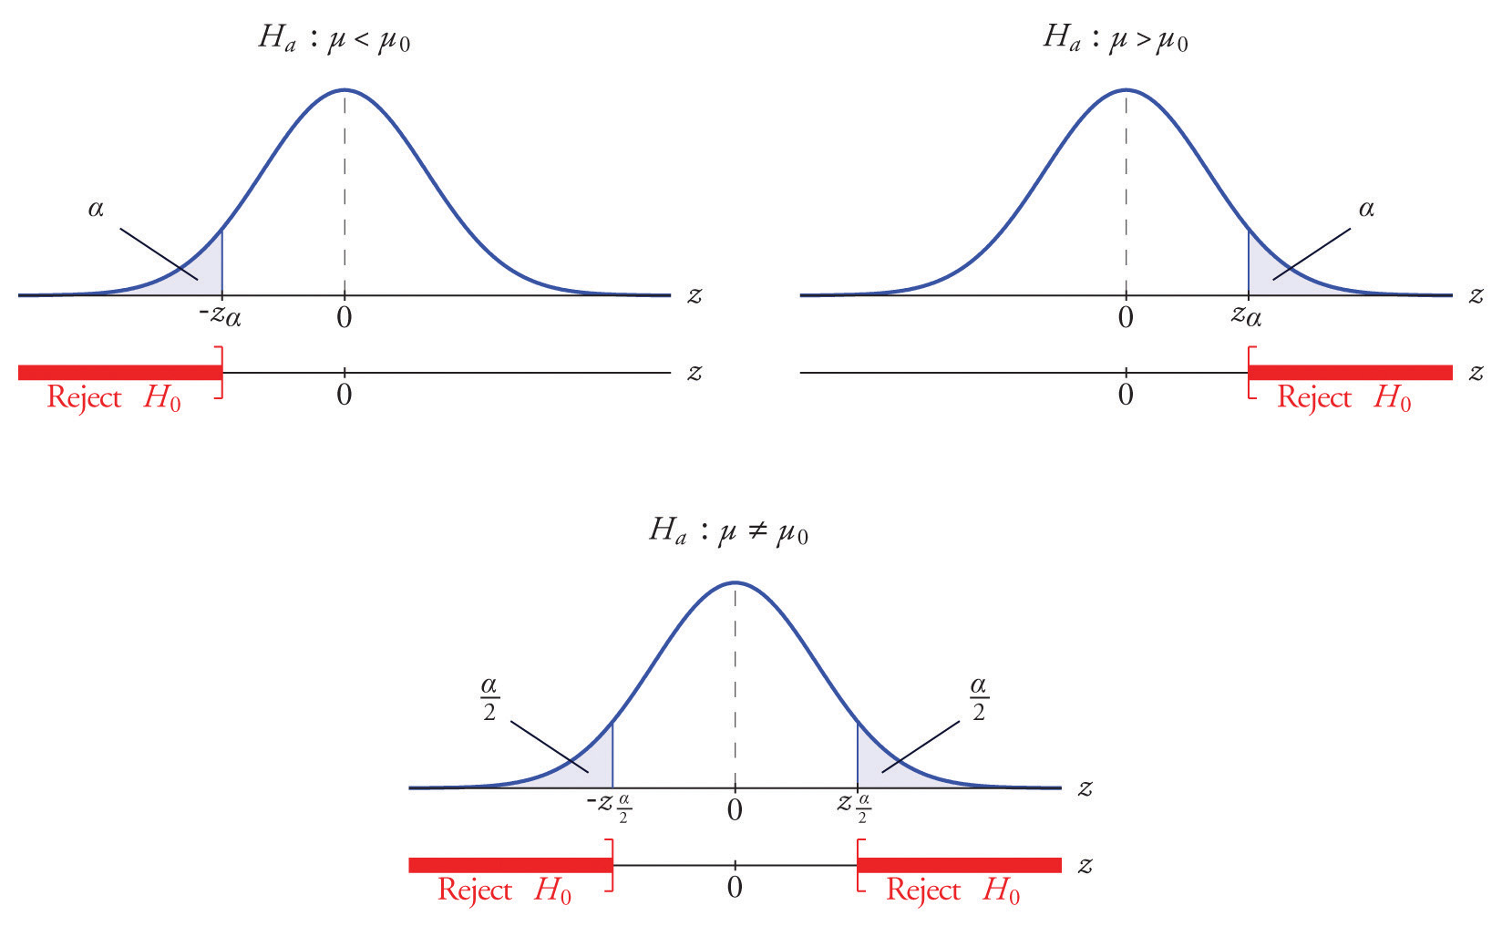

Two-tailed test

One-tailed test,

Right-tail

One-tailed test,

Left-tail

#### Test Statistic

The test statistic is the standardized sample statistic, $\overline{x} or \overline{p}$, under the assumption that the null hypothesis is true, i.e., the sample statistic is standardized using the mean of the status quo.

#### p-value

The p-value is the probability of observing the given sample statistic or of observing one with a more extreme value.

#### Conclusion and Interpretation of Results

The conclusion is determined by either…

* Comparing the test statistic to the critical value. If the test statistic is more extreme than the critical value, reject the null hypothesis. Otherwise, fail to reject the null hypothesis.
* Comparing the p-value to the significance level, α, in a one-tailed test or comparing the p-value to $\frac{α}{2}$ in a two-tailed test. If the p-value is less than α in a one-tailed test or less than $\frac{α}{2}$ in a two-tailed test, reject the null hypothesis. Otherwise, fail to reject the null hypothesis.

## Possibility of Error

Because hypothesis tests are based on limited sample information, we accept that we could make an error.

Two correct decisions are possible: rejecting the null hypothesis when the null hypothesis is false and failing to reject the null hypothesis when the null hypothesis is true.

Conversely, two incorrect decisions (errors) are also possible: rejecting the null hypothesis when the null hypothesis is true and failing to reject the null hypothesis when the null hypothesis is false.

|  |  |  |
| --- | --- | --- |
| **Decision** | **Null Hypothesis is True** | **Null Hypothesis is False** |
| **Reject the null hypothesis** | Type I Error ($α$) | Correct decision |
| **Fail to reject the null hypothesis** | Correct decision | Type II Error ($β$) |

Reducing one type of error increases the other. The only way to reduce both types of error is to collect more evidence, i.e., increase n.

# Steps of a Hypothesis Test

1. Specify the two hypotheses: Null and Alternative.

Three Steps to Formulate Hypotheses

* 1. Identify the relevant population parameter of interest (e.g., *μ* or *p*).
  2. Determine whether it is a one- or a two-tailed test.
  3. Include some form of the equality sign in *H0* and use *HA* to establish a claim.

|  |  |  |
| --- | --- | --- |
| ***H0*** | ***HA*** | **Test Type** |
| *=* | ≠ | Two-tail |
| *>* | < | One-tail, Left-tail |
| *<* | > | One-tail, Right-tail |

1. Specify the significance level, $α$, i.e., the probability of making a type I error. Find the critical values associated with $α$ for a one-tailed test or $\frac{α}{2}$ for a two-tailed test.
2. Calculate the value of a test statistic and the p-value.

|  |  |  |
| --- | --- | --- |
| **Test statistic** **for a** **Proportion** | $$z=\frac{\overline{p}-p_{0}}{\sqrt{\frac{p_{0}(1-p_{0})}{n}}}$$ | $p_{0}$ is the “status quo” population proportion specified in the null hypothesis $\overline{p}$ is the sample proportion |
| **Test statistic** **for a** **Mean** | $$t_{df}=\frac{\overline{x}-μ_{0}}{\frac{s}{\sqrt{n}}}$$ | $μ_{0}$ is the “status quo” population mean specified in the null hypothesis $\overline{x}$ is the sample mean |
| **Calculate the p-value** | Find the probability of observing the test statistic in its respective table, the $z or t_{df}$ table. This value is also available in the computer output after running a statistical test. | |

1. State the conclusion and interpret the results.
   1. State the conclusion as “Reject the null hypothesis” or “Fail to reject the null hypothesis.”
   2. Interpret the results in terms of the data.

|  |  |
| --- | --- |
| **Observation (Proportions)** | **Decision** |
| z > $z_{α}^{*}$ for a right-tailed test  z < ${-z}_{α}^{*}$ for a left-tailed test  z > $z_{\frac{α}{2}}^{*}$ or z < ${-z}_{\frac{α}{2}}^{*}$ for a two-tailed test | Reject the null hypothesis. |
| z ${≤z}_{α}^{*}$ for a right-tailed test $z$ ${≥-z}_{α}^{*}$ for a left-tailed test  z $≤$ $z_{\frac{α}{2}}^{*}$ or z $≥$ ${-z}_{\frac{α}{2}}^{*}$ for a two-tailed test | Fail to reject the null hypothesis. |
| p-value < $α$ for a right- or left-tailed test  p-value < $\frac{α}{2}$ for a two-tailed test | Reject the null hypothesis. |
| p-value $≥α$ for a right- or left-tailed test  p-value $≥\frac{α}{2}$ for a two-tailed test | Fail to reject the null hypothesis. |

|  |  |
| --- | --- |
| **Observation (Means)** | **Decision** |
| $t_{df}$ > $t_{α, df}^{*}$ for a right-tailed test $t_{df}$ < ${-t}_{α, df}^{*}$ for a left-tailed test $t_{df}$ > $t_{\frac{α}{2}, df}^{*}$ or $t_{df}$ < ${-t}_{\frac{α}{2}, df}^{*}$ for a two-tailed test | Reject the null hypothesis. |
| $t_{df}$ ${≤t}_{α, df}^{*}$ for a right-tailed test $t_{df}$ ${≥-t}_{α, df}^{*}$ for a left-tailed test $t_{df}$ $≤$ $t_{\frac{α}{2}, df}^{*}$ or $t_{df}$ $≥$ ${-t}_{\frac{α}{2}, df}^{*}$ for a two-tailed test | Fail to reject the null hypothesis. |
| p-value < $α$ for a right- or left-tailed test  p-value < $\frac{α}{2}$ for a two-tailed test | Reject the null hypothesis. |
| p-value for a right- or left-tailed test  p-value for a two-tailed test | Fail to reject the null hypothesis. |